CACFP NPA Message of the Month – November 2011
Website Update
Our new website is up and running now. Use this link to log in and look at many of the exciting features on the site: www.cacfpnpa.org. Current members will need a user name and password to log into this area. Until the website is fully functional, the user name is <member> and the password is <cacfpnpa> (all of these letters are in lower case). We have received many positive comments on our new website, so log in and take a look.
CACFP NPA Membership
The Membership form (http://www.cacfpnpa.org/2011-2013%20Membership%20Form%20State%20Agency.doc) was sent out last month to all members. If you have any questions or clarifications about membership payment; please contact Connie Bell at 505-827-9964 or email connie.bell@state.nm.us Membership registration is going on now, so please renew as soon as possible. This will ensure all information gets to you in a timely manner and you will receive a discount when you attend the conference in April. Your membership will be valid for two years, beginning October 1, 2011 and ending on September 30, 2013.
2012 CACFP NPA Conference
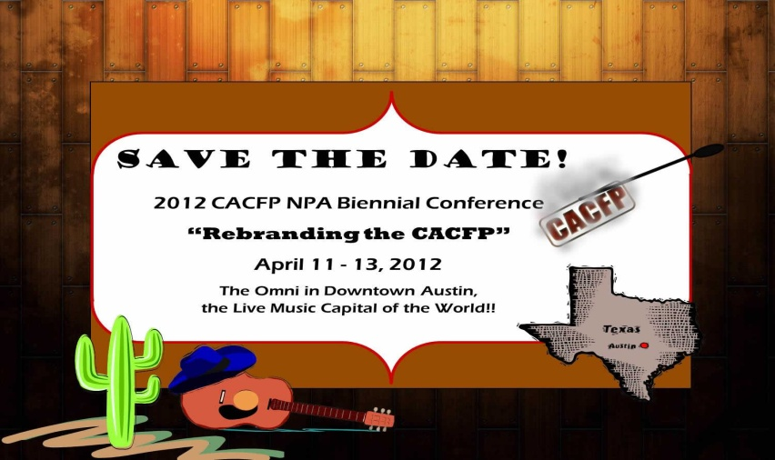
Remember the CACFP NPA conference in Austin, Texas on April 11th, 12th, and 13th, 2012. The theme for the conference is “Rebranding the CACFP.” Look for more information on our website in the near future.

- Make your reservations at the Omni for the conference using the link below...
http://www.omnihotels.com/FindAHotel/AustinDowntown/MeetingFacilities/CACFPNPA4.aspx

- Also, join the Omni Select Guest Program to enjoy the additional benefits the Omni has to offer(it’s free and includes wi-fi)… http://www.omnihotels.com/SelectGuestProgram/MemberBenefits.aspx

- The CACFP National Professional Association is looking for presenters for this conference. If you are interested, or you know someone who is, please submit a proposal on one of the attached “Call for Presenters” forms. We are providing the form in 2 formats for your convenience – MS Word or Adobe. If you choose the Adobe format, you must have Adobe Acrobat (as opposed to Adobe Reader) to save the completed form. When you have completed your form, simply attach it to an email and return it to Linda St. Clair at lsstclai@access.k12.wv.us or fax it to 304-558-1149. Questions? Call Linda at 304-558-3396.

- Exhibitors: We will be soliciting exhibitors for our expo, as well. Benedict Onye will be heading up the expo. For more information, contact Benedict at benedict.onye@ct.gov.

Paperwork Reduction Work Group
The CACFP Paperwork Reduction Work Group are meeting to discuss ideas to reduce paperwork that could be incorporated into the proposed rule to be released this spring regarding the Healthy, Hunger-Free Kids Act. They have been working on recommendations that can be addressed through clarification, encouraging best practices, and issuing memos or guidance. We may be asked to send in our comments and recommendations which is another good reason to become a member of the CACFP NPA.

Southwest Regional Representative
Curtis Curry has decided to leave state government and pursue other opportunities so he has stepped down from the board. Fortunately, Linda Simmons from the Texas Department of Agriculture, who was also on the ballot for this year, has agreed to take his place! She has officially accepted the CACFP NPA Southwest Regional Representative position and you can contact her at Linda.Simmons@texasagriculture.gov. Welcome Linda!

